Chapter-23
Pochampalli
1. Define weaving.
Ans: Weaving is a process of making cloth or fabric from a fibre on a loom.
2. Most families in Mukhtapur village are weavers. What cloth do they weave?
Ans;
3. Imagine you have to explain the entire process of making Pochampalli saree. Write down the steps.
Ans: The steps are:
i) Silk threads are bought from the market.
ii) Bundle of threads are washed in boiling water to wash away dirty and stains.
iii) The threads are dyed in bright colours.
iv) The threads are dryed and rolled into bundles.
v) The threads are put on to looms and a cloth is
woven.
4. Describe the importance of teamwork and how each family member’s contribution helps in creating a final product like the Pochampalli saree.
Ans:
5. Explain why the family craft of making Pochampalli sarees is in danger of being lost forever.
Ans: The reasons are:
- Silk is becoming expensive day by day.
- Weavers not getting good profit for their hard work.
- Workers are leaving the work in search of new profitable work.
6. Explain the life cycle of silk worm with a diagram.
Ans: The life cycle of a silkworm has four stages: egg, larva (caterpillar) pupa and moth.
- A female moth lays eggs.
- Eggs hatch into larvae that eat mulberry leaves and grow.
- Next , the larva forms a cocoon around itself and turns into a pupa inside.
- Finally , an adult moth emerges from the cocoon to start the cycle again.
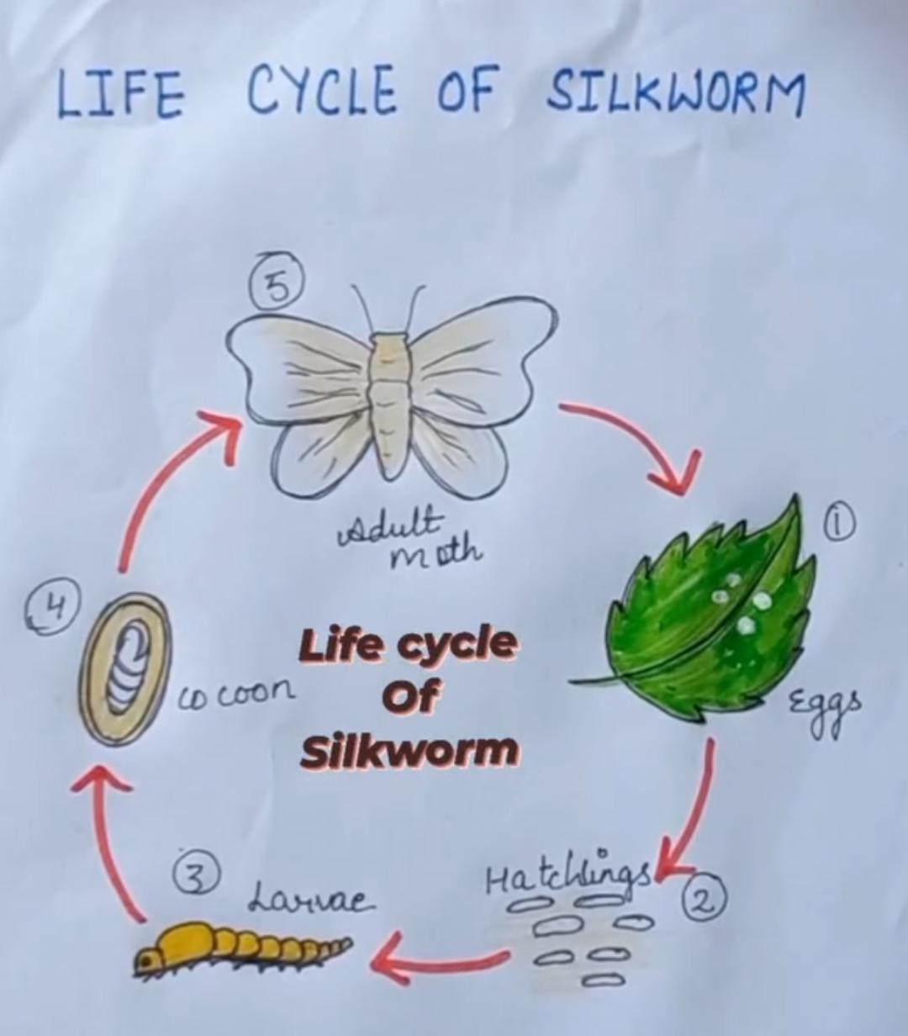

Home work
8. Write any 3 unique features of Pochampalli sarees.
9. At first silk was native to which country.
10. In the practice of many traditional crafts ,the entire family participate. Why do you think this is necessary?
11. Name the species of silk worm from which superior quality silk is produced in India.
12. Write the necessatiy of weaving cocoon in silkworm’s life cycle.

